**Day 7**

1.     Rank employees by their total sales

(Total sales = Total no of orders handled, JOIN employees and orders table)

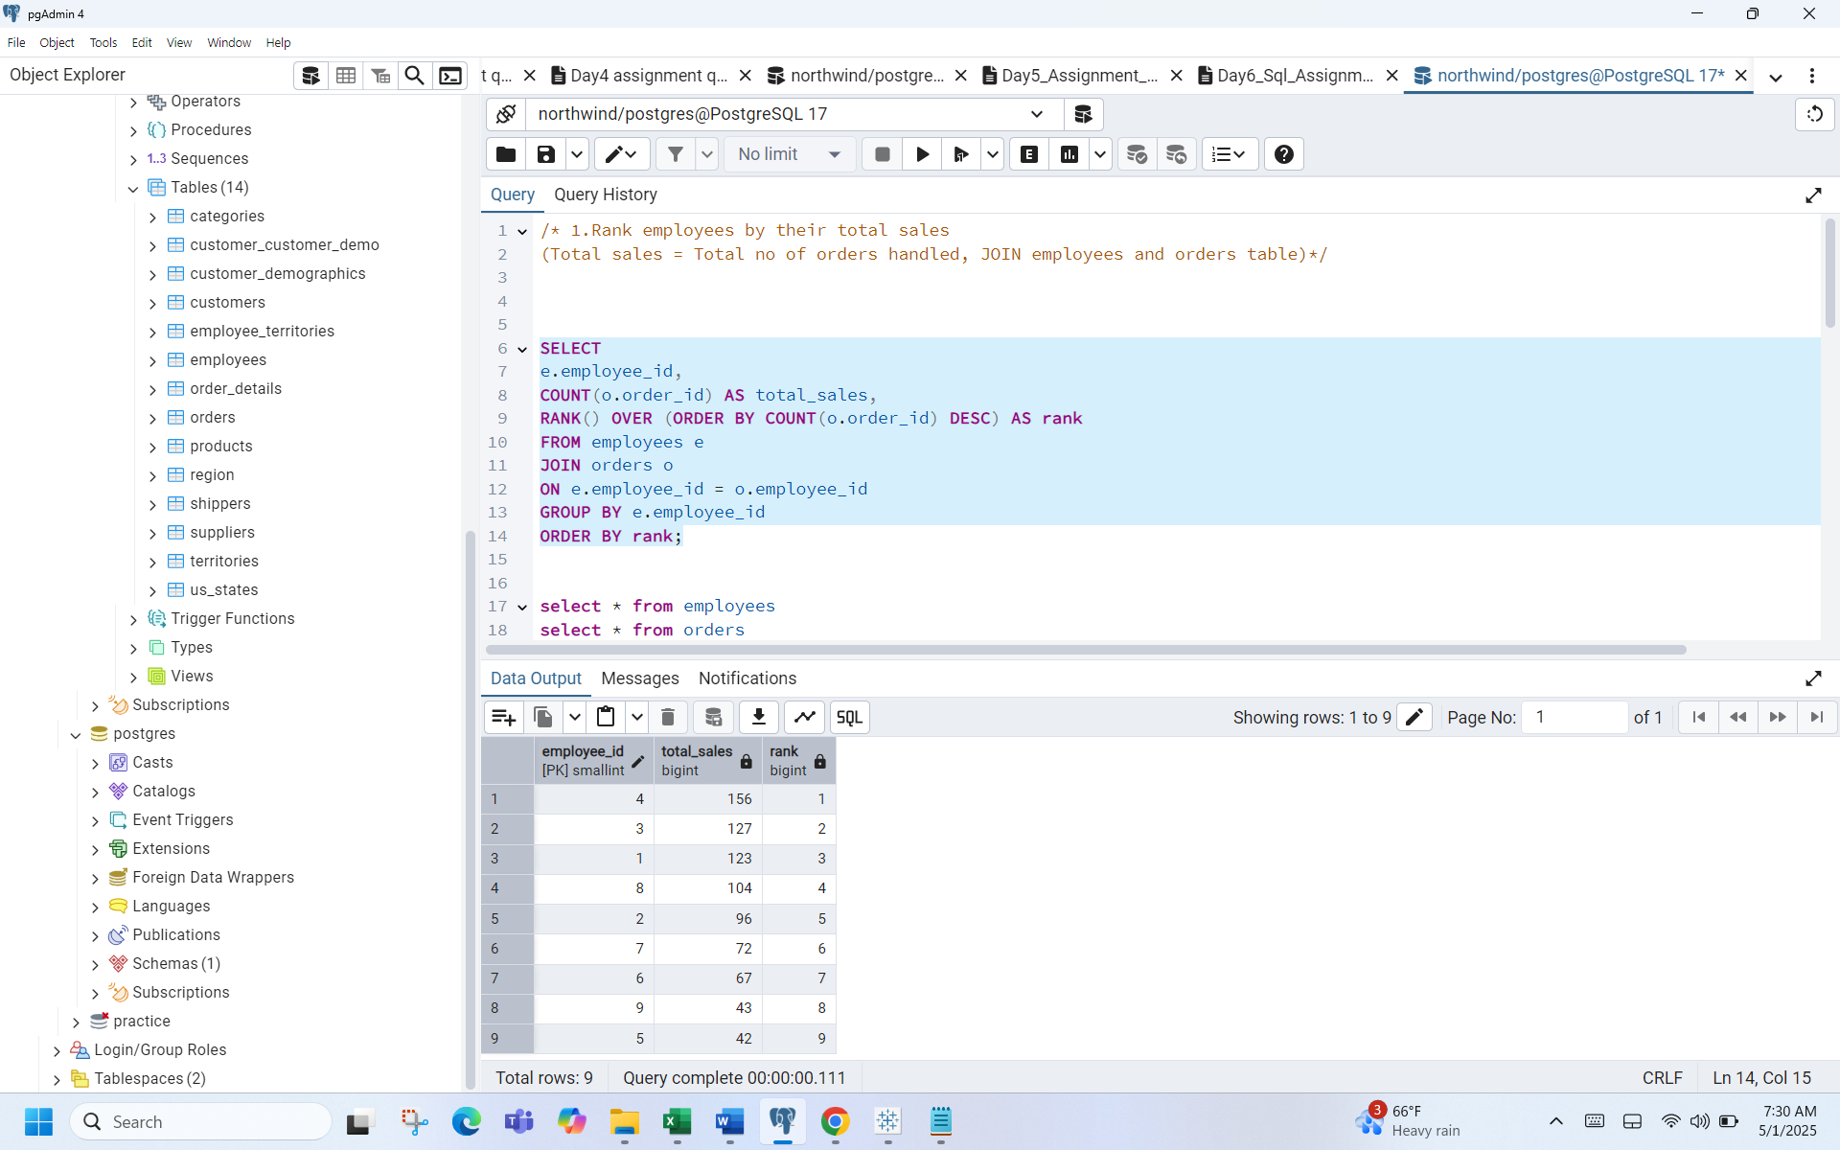

2.      Compare current order's freight with previous and next order for each customer.

(Display order_id,  customer_id,  order_date,  freight,

Use lead(freight) and lag(freight).

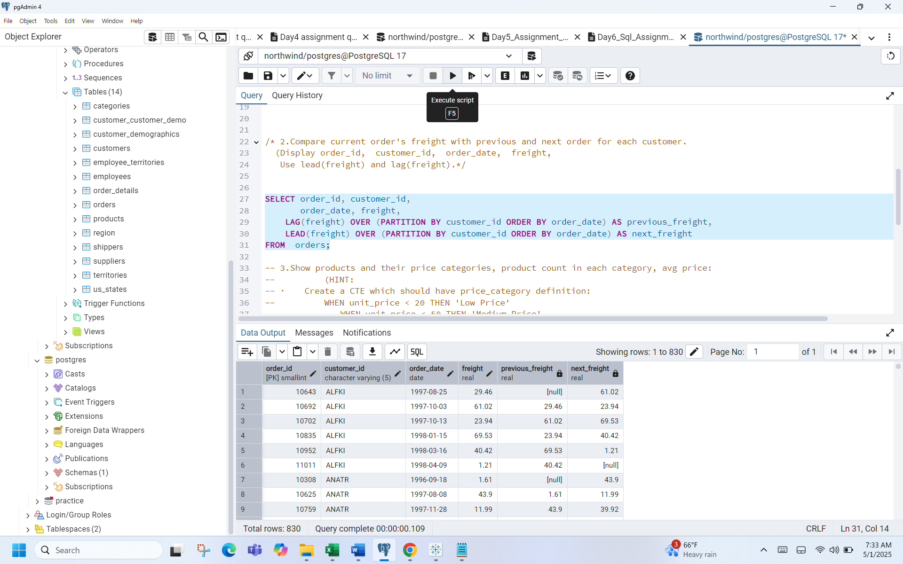

3.     Show products and their price categories, product count in each category, avg price:

(HINT:Create a CTE which should have price_category definition:

WHEN unit_price < 20 THEN 'Low Price'

WHEN unit_price < 50 THEN 'Medium Price'

ELSE 'High Price'

In the main query display: price_category, product_count in each price_category, ROUND(AVG(unit_price)::numeric, 2)

as avg_price)

